4-Bit Password Security System

**Submitted By**

| **Student Name** | **Student ID** |
| --- | --- |
| Abdus Salam | 0242310005101066 |
| Jawad Al Hasan | 0242310005101964 |
| Rakib Miah | 0242310005101734 |
| Nur Hossain Rhedoy | 0242310005101385 |
| Abdullah Al Mazbah | 0242310005101114 |

**PROJECT REPORT**

This Report Presented in Partial Fulfillment of the course **CSE224: Digital Logic Design Lab**



**DAFFODIL INTERNATIONAL UNIVERSITY**

**Dhaka, Bangladesh**

**November 2, 2024**

**DECLARATION**

We hereby declare that we have done this lab project under the supervision of **Name of the course teacher**, **course teacher’s Designation**, Department of Computer Science and Engineering, Daffodil International University. We also declare that neither this project nor any part of this project has been submitted elsewhere as lab projects.

**Submitted To:**

Zahura Zaman

**Course Teacher’s Name**

Designation

Department of Computer Science and Engineering Daffodil International University

**Submitted by**

| Md . Abdus Salam  0242310005101066  Dept. of CSE, DIU | |
| --- | --- |
| Md . Abdus Salam  0242310005101066  Dept. of CSE, DIU | Md . Abdus Salam  0242310005101066  Dept. of CSE, DIU |
| Md . Abdus Salam  0242310005101066  Dept. of CSE, DIU | Md . Abdus Salam  0242310005101066  Dept. of CSE, DIU |

**COURSE OUTCOME**

The following courses have course outcomes as follows:.

Table 1: Course Outcome Statements

| CO’s | Statements |
| --- | --- |
| CO1 | Basic knowledge of logic gate implementation and getting familiar with IC |
| CO2 | Understanding different combinational circuits and designing circuits |
| CO3 | Able to solve problems using sequential circuit and logic design |

### **Table of Contents**

1. **Title Page**
2. **Declaration**
3. **Chapter 1: Introduction**
   * Introduction
   * Motivation
   * Objectives
   * Feasibility Study
   * Gap Analysis
   * Project Outcome
4. **Chapter 2: Proposed Methodology/Architecture**
   * Requirement Analysis & Design Specification
   * Proposed Methodology/System Design
   * UI Design
   * Overall Project Plan
5. **Chapter 3: Implementation and Results**
   * Implementation
   * Performance Analysis
   * Results and Discussion
6. **Chapter 4: Engineering Standards and Mapping**
   * Impact on Society, Environment, and Sustainability
     + Impact on Life
     + Impact on Society & Environment
     + Ethical Aspects
     + Sustainability Plan
   * Project Management and Team Work
7. **Chapter 5: Conclusion**
   * Summary
   * Limitation
   * Future Work

**4-Bit Password Security System**

Submitted By

Student Name : **Abdus Salam**

Student ID : **0242310005101066**

MINI LAB PROJECT REPORT

This Report is Presented in Partial Fulfillment of the course CSE224: Subject Name in the Computer Science and Engineering Department

DAFFODIL INTERNATIONAL UNIVERSITY

Dhaka, Bangladesh

December 10, 2024

DECLARATION

We hereby declare that we have done this lab project under the supervision of Name of the course teacher, course teacher’s Designation, Department of Computer Science and Engineering, Daffodil International University. We also declare that neither this project nor any part of this project has been submitted elsewhere as lab projects.

**Chapter 1: Introduction**

**Introduction**

This chapter provides an overview of the "4-Bit Password Security System" project, focusing on its background and the problem it aims to address. Password security systems ensure restricted access to sensitive information or areas. A 4-bit password system offers a simple yet effective method for demonstrating security concepts in digital systems.

**Motivation**

The increasing need for secure authentication methods inspired the development of this project. This system demonstrates a practical implementation of basic digital logic to create a low-complexity password authentication mechanism.

**Objectives**

- To design and implement a 4-bit password-based security system.

- To ensure that the system validates user input correctly.

- To simulate and test the system using Proteus software.

- To demonstrate the practical application of digital logic components.

**Feasibility Study**

The project is based on digital logic components, such as logic gates, switches, and LEDs, readily available in simulation software like Proteus. This makes the project cost-effective and feasible within the lab environment.

**Gap Analysis**

While many password security systems exist, this project aims to simplify the concept for educational purposes. The primary gap addressed is the lack of practical examples demonstrating digital logic in password validation systems.

**Project Outcome**

The outcome of this project will be a functional 4-bit password security system capable of authenticating a user’s password and indicating access through an LED display.

**Chapter 2: Proposed Methodology/Architecture**

**Requirement Analysis & Design Specification**

**Overview**

The project employs a combination of DIP switches for user input, LEDs for output indication, and digital logic gates for password validation.

**Proposed Methodology/System Design**

1. Input Unit: Four DIP switches represent the 4-bit user input.

2. Processing Unit: AND and OR gates are used to validate the password.

3. Output Unit: LEDs indicate whether access is granted or denied.

**UI Design**

The system’s UI is minimal, involving DIP switches for password entry and LEDs for feedback.

**Overall Project Plan**

1. Design the circuit schematic in Proteus.

2. Simulate the circuit to verify functionality.

3. Implement the system in hardware (if required).

4. Document the project and analyze performance.

**Chapter 3: Implementation and Results**

**Implementation**

The system was implemented in Proteus using the following components:

- Logic gates: AND, OR, NOT

- Input: DIP switches

- Output: LEDs

**The schematic diagram is provided below:**

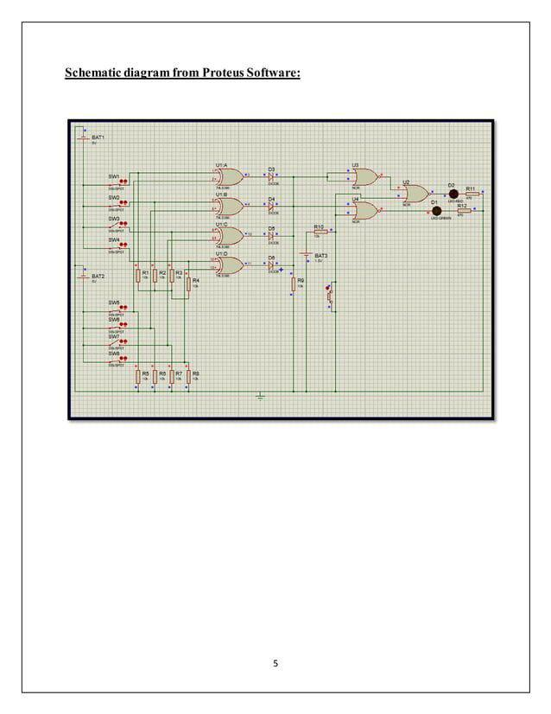

**Performance Analysis**

The system was tested with various 4-bit inputs to ensure the correct password activated the access LED, while incorrect passwords activated the denied LED.

**Results and Discussion**

The results demonstrated the successful implementation of the password validation mechanism. The system is robust for educational purposes and provides a clear understanding of basic digital logic operations.

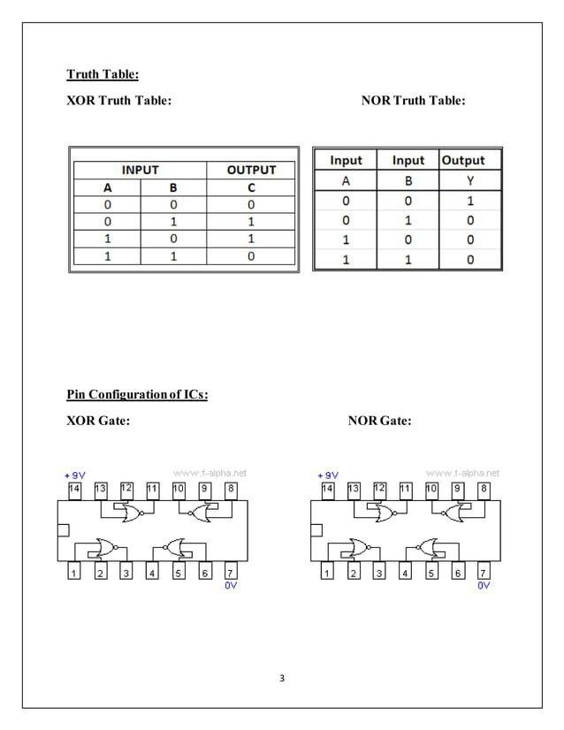

**Chapter 4: Engineering Standards and Mapping**

**Impact on Society, Environment, and Sustainability**

**Impact on Life**

The project provides insights into how digital systems can enhance security in everyday life.

**Impact on Society & Environment**

The project is environmentally friendly as it uses minimal resources and focuses on digital simulation.

**Ethical Aspects**

The project adheres to ethical guidelines by promoting knowledge without causing harm.

**Sustainability Plan**

The system can be scaled for more complex applications, ensuring long-term educational value.

Table: Mapping with complex problem-solving.

| **EP1**  Dept of Knowledge | **EP2**  Range of Conflicting Requirements | **EP3**  Depth of Analysis | **EP4**  Familiarity of Issues | **EP5**  Extent of Applicable Codes | **EP6**  Extent  Of Stakeholder Involvement | **EP7**  Inter- dependence |
| --- | --- | --- | --- | --- | --- | --- |
| Yes | Yes | Yes | Yes | No | No | No |

Table: Mapping with complex engineering activities.

| **EA1**  Range of resources | **EA2**  Level of Interaction | **EA3**  Innovation | **EA4**  Consequences for society and  environment | **EA5**  Familiarity |
| --- | --- | --- | --- | --- |
| Yes | Yes | Yes | No | No |

**Project Management and Team Work**

The project was managed in stages, from design to testing, with clear roles for team members.

**Chapter 5: Conclusion**

**Summary**

This project successfully demonstrates a functional 4-bit password security system using digital logic components.

**Limitation**

The system supports only a single predefined password and lacks scalability for multiple users.

**Future Work**

Future improvements could include:

- Adding support for variable password lengths.

- Integrating a display for better user interaction.

- Implementing the system on a hardware platform.